**Xray Results**

**Summary Table: Performance Comparison**

| **Model** | **Precision** | **Recall** | **F1 Score** | **Accuracy** |
| --- | --- | --- | --- | --- |
| **VGG16 (ReLU)** | 0.96% | 0.96% | 0.96% | 0.96% |
| **VGG16 (Swish)** | 0.95% | 0.95% | 0.95% | 0.95% |
| **Inception (ReLU)** | 0.96 | 0.96 | 0.96 | 0.96 |
| **Inception (Swish)** | 0.57 | 0.54 | 0.53 | 0.54 |
| **ResNet (ReLU)** | 0.89 | 0.88 | 0.88 | 0.88 |
| **ResNet (Swish)** | 0.92 | 0.92 | 0.92 | 0.92 |
| **DenseNet (ReLU)** | 0.97 | 0.97 | 0.97 | 0.97 |
| **DenseNet (Swish)** | 0.95 | 0.95 | 0.95 | 0.95 |

**VGG16 model with ReLU activation**

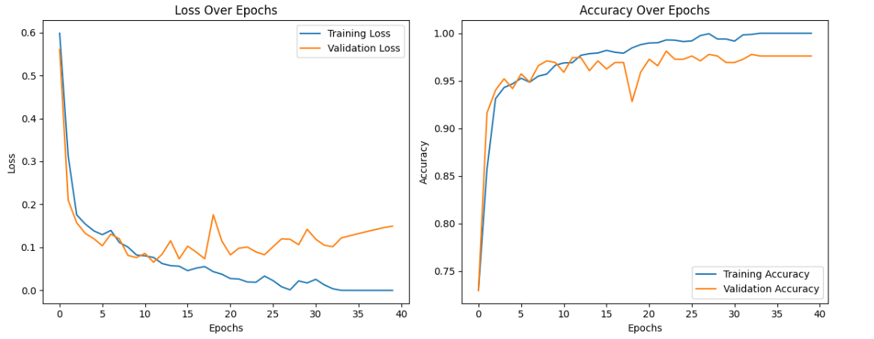

**VGG16 with Swish on Chest X-Ray Dataset**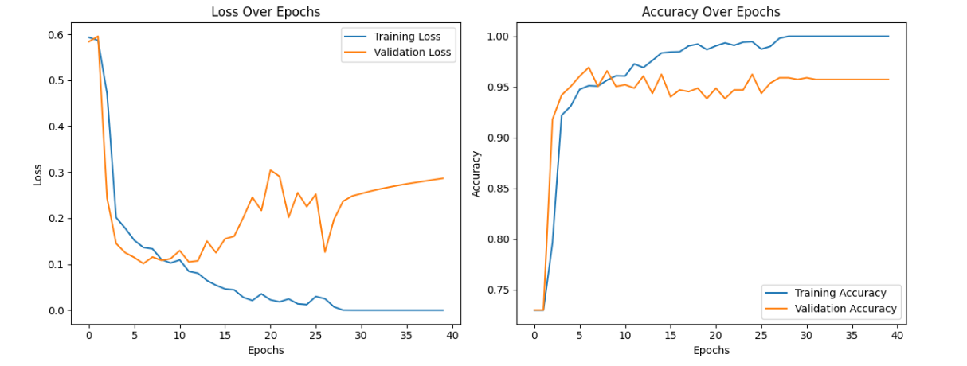

**Inception (ReLU Activation)**

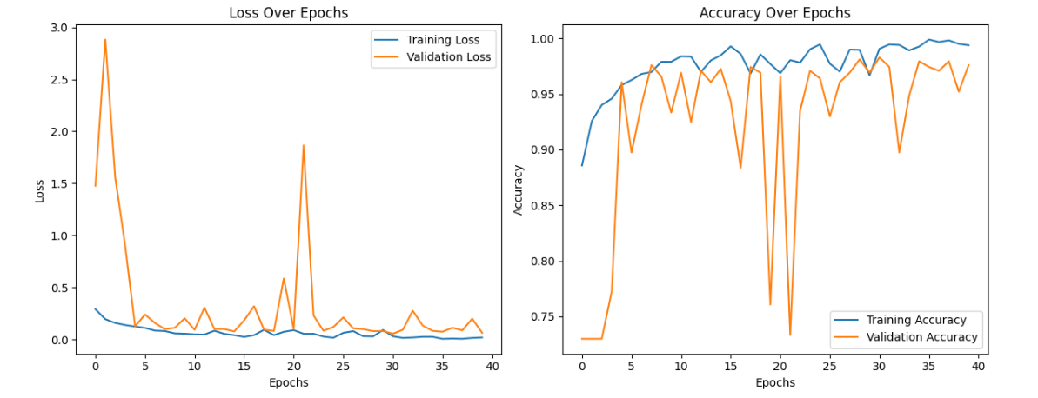

**Inception (Swish Activation)**

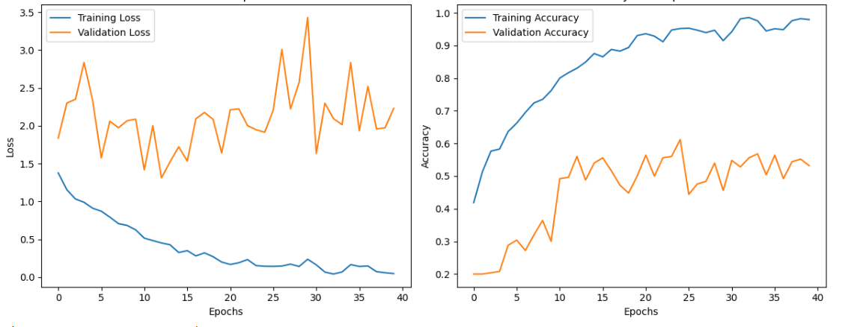

**ResNet (Relu Activation)**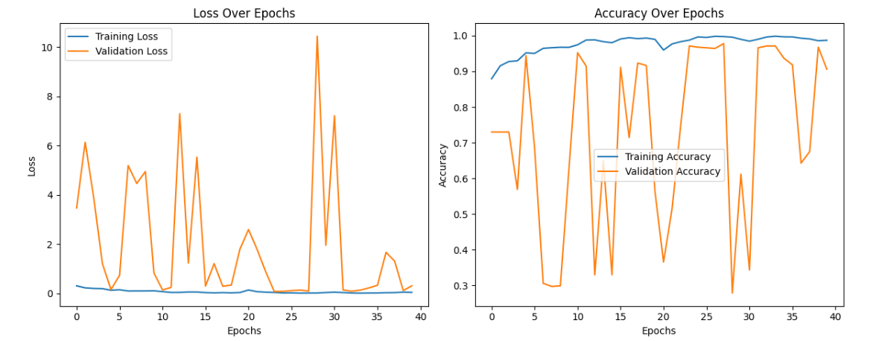

**.**

**ResNet (Swish Activation)**

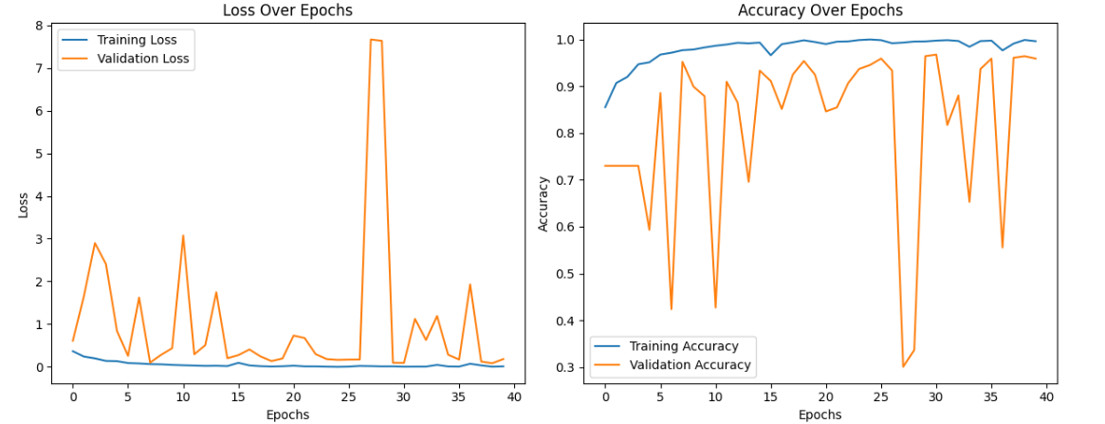

**DenseNet (ReLU Activation)**

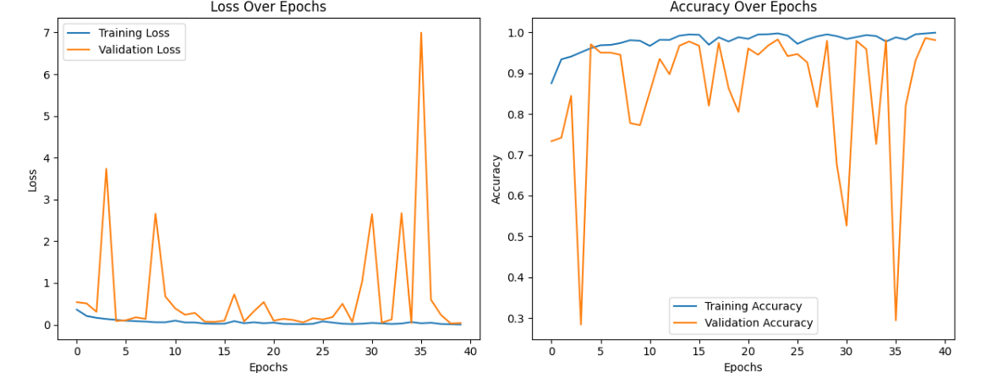

**DenseNet (Swish Activation)**

